**Response for Assignment 4.1**

Below screenshot shows the output of the Program (with class concepts) to find the area of the triangle using the below formula.

area = (s*(s-a)*(s-b)*(s-c)) ** 0.5

Function to take the length of the sides of triangle from user should be defined in the parent

class and function to calculate the area should be defined in subclass.

**Parent Class Definition**

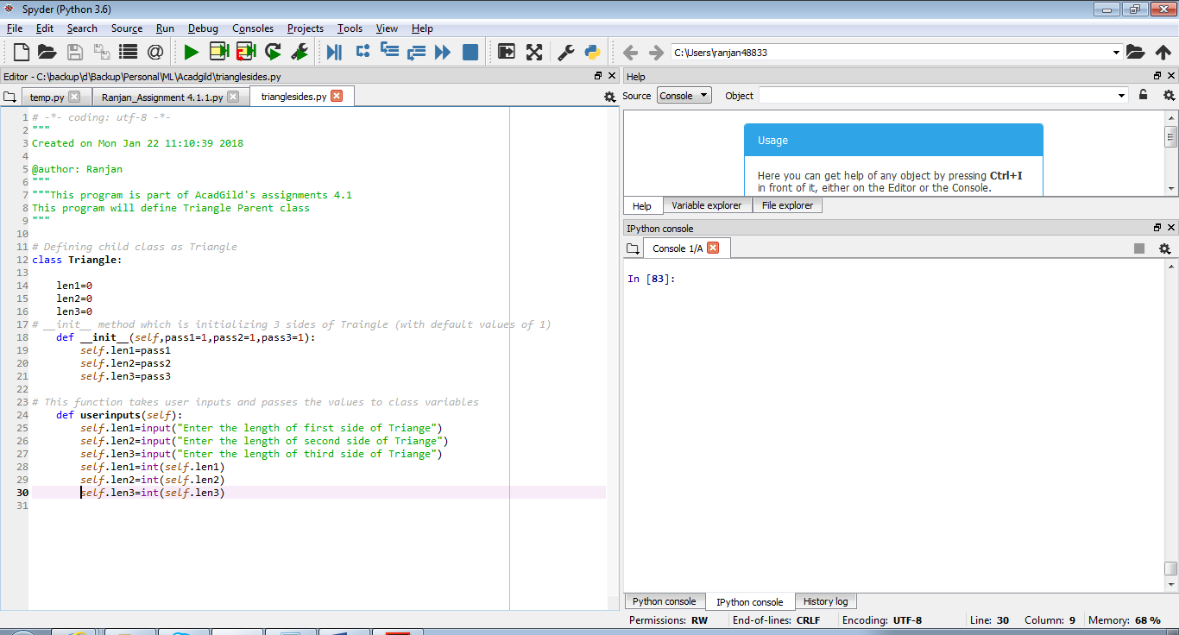

**Source Code**

# Defining child class as Triangle

class Triangle:

len1=0

len2=0

len3=0

# __init__ method which is initializing 3 sides of Traingle (with default values of 1)

def __init__(self,pass1=1,pass2=1,pass3=1):

self.len1=pass1

self.len2=pass2

self.len3=pass3

# This function takes user inputs and passes the values to class variables

def userinputs(self):

self.len1=input("Enter the length of first side of Triange")

self.len2=input("Enter the length of second side of Triange")

self.len3=input("Enter the length of third side of Triange")

self.len1=int(self.len1)

self.len2=int(self.len2)

self.len3=int(self.len3)

**Child Class Program**

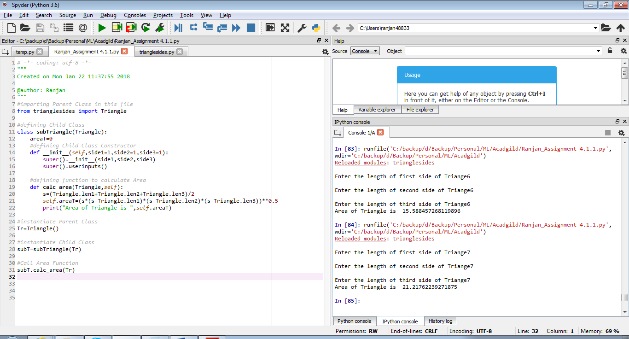

**Source Code**

#importing Parent Class in this file

from trianglesides import Triangle

#defining Child Class

class subTriangle(Triangle):

areaT=0

#defining Child Class Constructor

def __init__(self,side1=1,side2=1,side3=1):

super().__init__(side1,side2,side3)

super().userinputs()

#defining function to calculate Area

def calc_area(Triangle,self):

s=(Triangle.len1+Triangle.len2+Triangle.len3)/2

self.areaT=(s*(s-Triangle.len1)*(s-Triangle.len2)*(s-Triangle.len3))**0.5

print("Area of Triangle is ",self.areaT)

#instantiate Parent Class

Tr=Triangle()

#instantiate Child Class

subT=subTriangle(Tr)

#Call Area Function

subT.calc_area(Tr)

**Problem Statement # 2**

This program creates function filter_long_words() that takes a list of words and an integer n and returns the list of words that are longer than n.

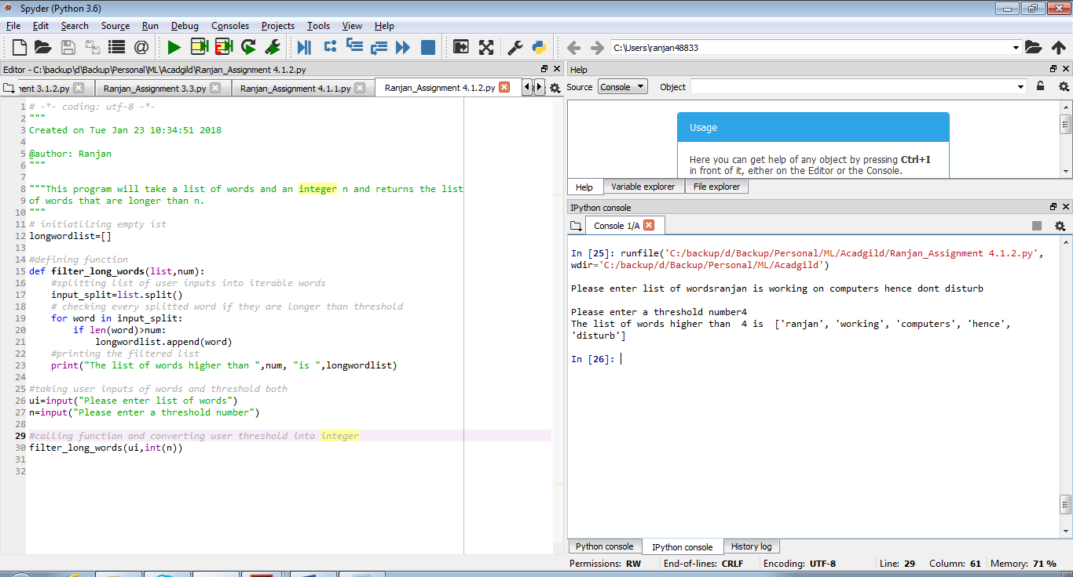

**Source Code**

# initiatlizing empty ist

longwordlist=[]

#defining function

def filter_long_words(list,num):

#splitting list of user inputs into iterable words

input_split=list.split()

# checking every splitted word if they are longer than threshold

for word in input_split:

if len(word)>num:

longwordlist.append(word)

#printing the filtered list

print("The list of words higher than ",num, "is ",longwordlist)

#taking user inputs of words and threshold both

ui=input("Please enter list of words")

n=input("Please enter a threshold number")

#calling function and converting user threshold into integer

filter_long_words(ui,int(n))